**Timers**

Timers allow JMeter to delay between each request which a thread makes. Timer can solve the server overload problem.

Also, in real life visitors do not arrive at a website all at the same time, but at different time intervals. So Timer will help mimic the real time behavior.

There are different types of Timer. They are:-

* Constant Timer
* Gaussian Random Timer

## Uniform Random Timer

* Synchronizing Timer

1. **Constant Timer:**  If you want to have each thread pause for the same amount of time between requests, use this timer.

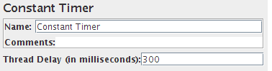

**Parameters:**

|  |  |  |  |  |  |  |  |  |
| --- | --- | --- | --- | --- | --- | --- | --- | --- |
| |  |  |  |  |  |  |  |  | | --- | --- | --- | --- | --- | --- | --- | --- | | |  |  |  |  |  |  |  | | --- | --- | --- | --- | --- | --- | --- | | |  |  | | --- | --- | | **Attribute** | **Description** | | Name | Descriptive name for this timer that is shown in the tree. | | Thread Delay | Number of milliseconds to pause. | | | |

1. **Gaussian Random Timer:** This timer pauses each thread request for a random amount of time, with most of the time intervals occurring near a particular value. The total delay is the sum of the Gaussian distributed value (with mean 0.0 and standard deviation 1.0) times the deviation value you specify, and the offset value. Another way to explain it, in Gaussian Random Timer, the variation around constant offset has a Gaussian curve distribution.

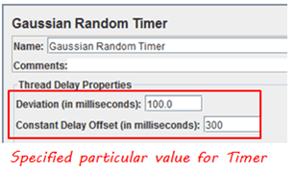

**Parameters:**

|  |  |  |  |  |  |  |  |  |  |  |
| --- | --- | --- | --- | --- | --- | --- | --- | --- | --- | --- |
| |  |  |  |  |  |  |  |  |  |  | | --- | --- | --- | --- | --- | --- | --- | --- | --- | --- | | |  |  |  |  |  |  |  |  |  | | --- | --- | --- | --- | --- | --- | --- | --- | --- | | |  |  | | --- | --- | | **Attribute** | **Description** | | Name | Descriptive name for this timer that is shown in the tree | | Deviation | Deviation in milliseconds. | | Constant Delay Offset | Number of milliseconds to pause in addition to the random delay. | | | |

## Uniform Random Timer: This timer pauses each thread request for a random amount of time, with each time interval having the same probability of occurring. The total delay is the sum of the random value and the offset value.

## http://cdn.guru99.com/images/UniformRandomTimer(1).png

## Parameters:

|  |  |  |  |  |  |  |  |  |  |  |
| --- | --- | --- | --- | --- | --- | --- | --- | --- | --- | --- |
| |  |  |  |  |  |  |  |  |  |  | | --- | --- | --- | --- | --- | --- | --- | --- | --- | --- | | |  |  |  |  |  |  |  |  |  | | --- | --- | --- | --- | --- | --- | --- | --- | --- | | |  |  | | --- | --- | | **Attribute** | **Description** | | Name | Descriptive name for this timer that is shown in the tree. | | Random Delay Maximum | Maxium random number of milliseconds to pause. | | Constant Delay Offset | Number of milliseconds to pause in addition to the random delay. | | | |

1. **Synchronizing Timer:** The purpose of the SyncTimer is to block threads until X numbers of threads have been blocked, and then they are all released at once. A SyncTimer can thus create large instant loads at various points of the test plan.

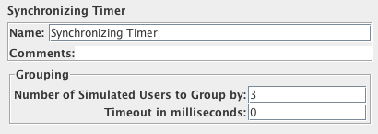

**Parameters:**

|  |  |  |  |  |  |  |  |  |  |  |
| --- | --- | --- | --- | --- | --- | --- | --- | --- | --- | --- |
| |  |  |  |  |  |  |  |  |  |  | | --- | --- | --- | --- | --- | --- | --- | --- | --- | --- | | |  |  |  |  |  |  |  |  |  | | --- | --- | --- | --- | --- | --- | --- | --- | --- | | |  |  | | --- | --- | | **Attribute** | **Description** | | Name | Descriptive name for this timer that is shown in the tree. | | Number of Simultaneous Users to Group by | Number of threads to release at once. Setting it to 0 is equivalent to setting it to Number of threads in Thread Group. | | Timeout in milliseconds | If set to 0, Timer will wait for the number of threads to reach the value in "Number of Simultaneous Users to Group", if superior to 0, then timer will wait at max "Timeout in milliseconds" if number of Threads does not reach if ater the timeout interval the number of users waiting is not reached, timer will stop waiting. Defaults to 0 | | | |